**Daily Scrum or Standup Meeting**

Team name: 5th Element

Scrum Master: Leonardo Craven

Date: November 9, 2021

| **Team Member** | **What did you do since the last scrum?** | **What do you plan to do before the next scrum?** | **What obstacles do you have?** |
| --- | --- | --- | --- |
| Leo | Finish editing README | Work on drink order notification system, might wait until navigation sidebar ready (done Thursday) | None |
| Gavin | Finish current drink orders for users page  Worked on menu population migration | Finish menu population migration (done today) | None |
| Andrew (not present at meeting) | Worked on navigation sidebar | Work on navigation sidebar | None |
| Brock | Worked on money account support  Finished adding company money account | Finish migration of company accounts, finish support for refunds on deleted tournament sponsorships (done Wednesday) | None |

# Burndown

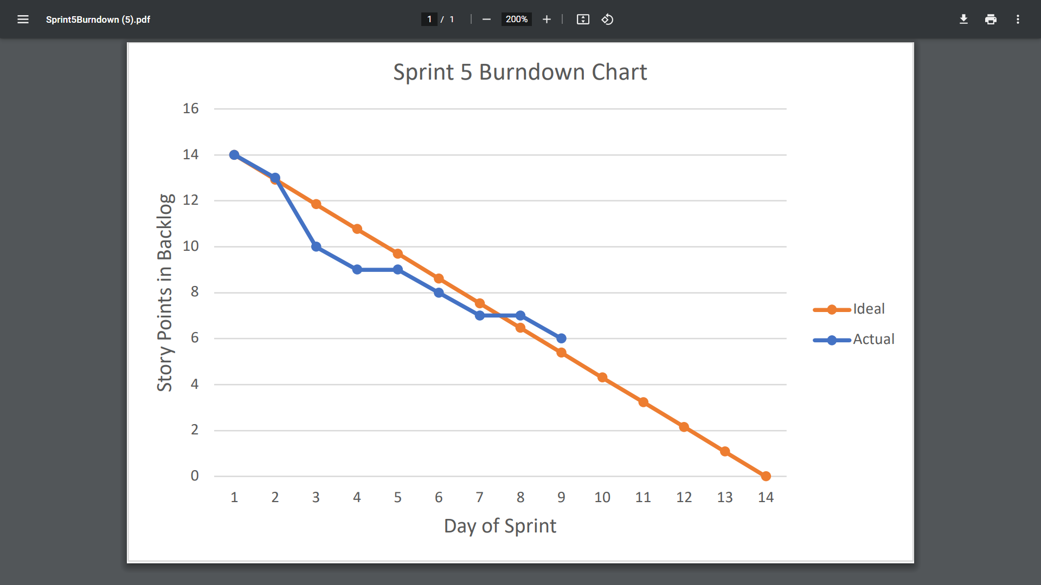

# Screenshot of you project board

